**Furniture Recommendation System**

#### A PROJECT REPORT

***Submitted by* Umang Dobariya 190110107014**

***In partial fulfillment for the award of the***

***degree of***

# BACHELOR OF ENGINEERING

***in***

**Computer Engineering**

**G. H. Patel College Of Engineering & Technology Vallabh Vidhyanagar**



**Gujarat Technological University, Ahmedabad**

#### [April, 2023]

 

**G. H. Patel College Of Engineering & Technology**

**Near Bakrol Gate, Vallabh Vidhyanagar, Anand-388120**

# CERTIFICATE

This is to certify that the project report submitted along with the project entitled **Furniture Recommendation system** has been carried out by **Umang Dobariya** under my guidance in partial fulfillment for the degree of Bachelor of Engineering in Computer Engineering ,8th Semester of Gujarat Technological University, Ahmadabad during the academic year 2022-23.

Prof. Sneh Vyas Dr. Maulika Patel

Internal Guide Head of the Department

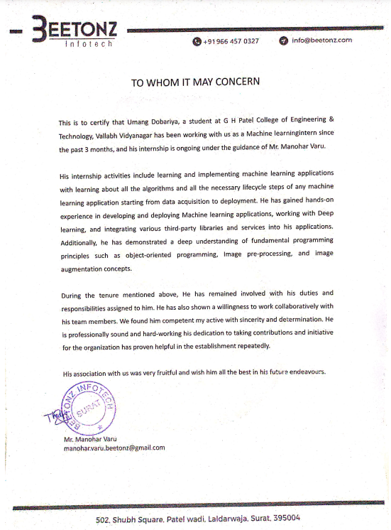

 

**DECLARATION**

We hereby declare that the Internship report submitted along with the Internship entitled Furniture Recommendation System submitted in partial fulfillment for the degree of Bachelor of Engineering in Computer Engineering to Gujarat Technological University, Ahmedabad, is a bonafide record of original project work carried out by me at Beetonz Infotech under the supervision of Manohar varu and that no part of this report has been directly copied from any students’ reports or taken from any other source, without providing due reference.

Name Of Student Signature

Umang Dobariya

## ACKNOWLEDGEMENT

I would like to extend my hearty thanks with a deep sense of gratitude and respect to all those who provides me immense help and guidance during my Internship .

I would like to thank our Head of Department **Dr. Maulika Patel** for providing a vision about the Internship. I have been greatly benefited from their regular critical reviews and inspiration throughout my work.

I would like to express our sincere thanks to my internal guide Assistant Professor **Sneh Vyas** who gave me an opportunity to undertake such a challenging and great innovative work. We are grateful to them for their guidance, encouragement, understanding and insightful support in the development process.

I would like to extend my heartiest thanks to **Mr.Haribhai Sonani** And **Mr. Manohar varu** (Software Engineer, Beetonz Infotech), for supporting me during the internship period. He guided us all the time and motivated us within his busy schedule.

Last but not the least we would like to mention here that we are greatly indebted to each and everybody who has been associated with my internship at any stage but whose name does not find a place in this acknowledgment.

.

Thank You

Umang Dobariya

## ABSTRACT

A furniture recommendation system is an intelligent software program that suggests furniture items to users based on their preferences, needs, and budget. Recommendation systems are a type of artificial intelligence technology that provide personalized suggestions to users based on their past behavior, preferences, and other relevant data. Furniture recommendation systems are designed to enhance the user's shopping experience by providing personalized and relevant product recommendations. By reducing the time and effort required for users to search for furniture items, these systems can improve customer satisfaction and increase sales for businesses. Some challenges of furniture recommendation systems include dealing with incomplete or inaccurate user data, managing the diversity of furniture items, and balancing the need for personalized recommendations with the need for serendipity and exploration. However, with advances in data science and artificial intelligence, furniture recommendation systems are becoming increasingly sophisticated and effective .This project is all about recommendation engines.

**List of Figures**

Figure 2.2.1 Schematic layout of sequence of operation 13

Figure 3.6.1 Agile SDLC 18

Figure 3.6.2 Flow of Kanban Development Methodology 19

Figure 5.1.1 Recommendation systems types 28

Figure 5.1.2 Basic Machine learning app lifecycle 29

Figure 5.2.1 Use case Diagram 29

Figure 5.2.2 System Context Diagram 29

Figure 5.2.3 Sequance Diagram 30

Figure 5.2.4 Block Diagram 30

Figure 5.2.5 Entire Process 31

Figure 5.3.1 Home Page 31

Figure 5.3.2 Basic UI 32

Figure 5.3.3 Recommendation with beds 32

Figure 5.3.4 Single bed image zoom in 33

Figure 5.3.5 Recommendation with chair 33

Figure 6.1.1 ResNet50 Architecture 34

Figure 7.1.1 Deployment Pipeline 45

Figure 7.2.1 Test Case Classification 46

## Table Of Content

Declaration iv

Acknowledgement v

Abstract vi

List of Figures vii

### Chapter 1: Overview of the Company 1

* 1. Introduction 1
  2. History 1
  3. Different Product / Scope of work 1

### Chapter 2: Overview of the different department of the organization and Layouts of the process being carried out in company 2

* 1. List of technical specifications of major equipment used in each

department 2

* 1. Prepare schematic layout which shows the sequence of the operation for the manufacturing of the end point 7

### Chapter 3: Introduction of the Project 8

* 1. Internship Summary 8
  2. Purpose 9
  3. Objective 9
  4. Scope (What it can do and can’t do) 9
  5. Technology and Literature Review 10
  6. Internship Planning 11
     1. Internship Development Approach and justification 11
     2. Role And Responsibilities 13

### Chapter 4: System Analysis 14

* 1. Study of Current System… 14
  2. Problem and Weakness of Current System 14
  3. Requirements of New System… 14
  4. System Feasibility 15
  5. Activity / Process in New System / Proposed System… 15
  6. Features of New System / Proposed System… 16
  7. List Main Modules / Components / Processes / Techniques of New System / Proposed System… 17
  8. Selection of Hardware / Software / Algorithms / Methodology / Techniques / Approaches and Justification 17

### Chapter 5: System Design… 19

* 1. System Design and Methodology 19
  2. Input / Output and Interface Design 20

### Chapter 6: Implementation 27

* 1. Implementation Platform / Environment 27
  2. Process / Program / Technology / Modules Specifications 28
  3. Findings / Results / Outcomes 28
  4. Result Analysis / Comparison / Deliberations 28

### Chapter 7: Testing 30

* 1. Testing Plan / Strategy 30
  2. Test Results and Analysis 30

### Chapter 8: Conclusion and Discussion 32

* 1. Conclusion 32
  2. Summary of Internship / Project work 32
  3. Limitation and Future Enhancement 32

### References 34

# CHAPTER 1:

## OVERVIEW OF COMPANY

* 1. **Introduction**

Beetonz Infotech is a company founded by two young entrepreneurs with a peerless passion for software development. Our talents cover a vast array of fields, ranging from web development to mobile applications development.

## History

The company name is Beetonz InfoTech. This is Surat based company and working on Service Provider of services, management software & healthcare in all over the globe .

Beetonz Infotech combines a passion for client satisfaction, technology innovation, deep Industry and business process expertise and a global, collaborative workforce that embodies the future of work. Once upon a time started Beetonz Infotech with 3 Members in 2012 and As year By year Passes with the Growth of Technology we are working 60+ Employee under one roof. Company is Working on Android Mobile Apps Development, I-Phone Apps Development and Game Development with the latest App Development Techniques and Tools. We at Beetonz Infotech Focus more with Current latest Market Technology with the Personal growth of all the employee. And Beetonz Infotech Provides Good Quality Service products For the Society.

"Partnering with global clients to master their biggest challenges, Beetonz Combines a passion for client satisfaction, technology innovation, deep industry and business process expertise, and global, collaborative workforce that embodies the future of work.

## Different Product / Scope of Work

* Ios app Development.
* Game Development.
* E-Commerce.
* Android App Development.
* CRM.
* Analytics.

# CHAPTER 2:

## OVERVIEW OF DEPARTMENT IN ORGANIZATION AND LAYOUTS OF PROCESS BEING CARRIED OUT IN COMPANY

* 1. **LIST OF TECHNICAL SPECIFICATION OF MAJOR EQUIPMENT USED IN EACH DEPARTMENT**

### Software Engineering

A Software Developer is a person responsible for the effective operations, maintenance and upgradation of business software's used in organizations for effective business solutions. Prime responsibilities include programming computer controls, working with business analyst to develop project implementation and develop plans including user interfaces, modifying IT systems already in use, developing code and debugging across a variety of products, testing new software, fixing any technical problems while testing, designing, prototyping, etc. varying on the organizational requirements. Key skills required are excellent knowledge and understanding of CASE (Computer Aided Software Engineering) tools, working knowledge of key languages.

#### Technical Requirements:

* + - * Web designing with HTML5/CSS3, Bootstrap, Javascript
      * React JS, Node JS, GraphQL, Sequelize , MongoDB.
      * Knowledge of the software development life cycle
      * Ability to develop unit testing of code components or complete applications

### Business Analyst

Business Analyst / Technical Support position is for candidates with ability to grasp technical details and analyze Client issues. If you have analytical thinking with good communication skills, then this job is for you. The candidate will have the opportunity to work with Clients to understand their Business Requirement and get it implemented by coordinating it with the engineering team. Some of the technical requirements can be managed by configuring the system without needing to involve engineers. The job also entails monitoring various production system alerts, coordination with engineers or call client to resolve specific issue. If the candidate shows business skills over the period of time, then they can also grow in to Business Development and Marketing function. Showing higher coordination and analytical thinking allows them to grow in higher role to manage other resources.

#### Responsibilities:

* + - * Monitor Production Systems to troubleshoot any issues and communicate with client, or coworker
      * Operations requires addressing client/production issues via email, phone, fax, text- messaging and ticketing system with existing and new Clients
      * Acquire knowledge through trainings and self-learning to become subject matter expert on Products and Services offered to the clients
      * Gather and analyze information, evaluate impacts, resolve or escalate issues as needed
      * Manage client expectations
      * Be flexible to be on rotational on-call as needed
      * Co-ordinate & facilitate functional testing for deployment of product upgrades
      * Implement Configurations and Changes to applications (training provided)

### Graphic Designer

Graphic Designers create visual concepts to communicate information. They create everything from posters and billboards to packaging, logos and marketing materials. Graphic Designers use elements such as shapes, colors, typography, images and more to convey ideas to an audience. Graphic Designers can work in-house, creating designs specifically for one brand, or at an agency or as a freelancer, where they work with a variety of clients.

The role of Graphic Designers varies depending on where they work. Some tasks that designers may work on include selecting photos and typefaces, developing layouts, and designing logos. Graphic Designers may specialize in a particular area, such as motion graphics or print media.

Graphic Designers often need to communicate with clients and consumers to develop designs that portray an intended message. They also collaborate with other graphic designers, marketers, business analysts, writers, and programmers to create successful products, campaigns, or websites.

#### Responsibilities:

* + - * Meet with clients or the art director to determine the scope of a project
      * Use digital illustration, photo editing software, and layout software to create designs
      * Create visual elements such as logos, original images, and illustrations to help deliver a message
      * Design layouts, including selection of colors, images, and typefaces
      * Present design concepts to clients or art directors
      * Incorporate changes recommended by clients or art directors into final designs
      * Review designs for errors before printing or publishing them

### HR

A Human Resources (HR) Officer is responsible for managing every aspect of the employment process, including orientation and training new staff members. They also assist with payroll management, so employees receive their paychecks on time.

They are responsible for managing every aspect of the employment process, including, orientation, and training of new staff members, and managing payroll.

#### Responsibilities:

* + - * Support the development and implementation of HR initiatives and systems
      * Provide counseling on policies and procedures
      * Be actively involved in recruitment by preparing job descriptions, posting ads and managing the hiring process
      * Create and implement effective onboarding plans
      * Develop training and development programs
      * Assist in performance management processes
      * Support the management of disciplinary and grievance issues
      * Maintain employee records (attendance, EEO data etc.) according to policy and legal requirements
      * Review employment and working conditions to ensure legal compliance

### Sales & Marketing

In addition to managing staff, the sales and marketing manager’s job responsibilities include developing and researching marketing opportunities and sales strategies. Ensure that these job responsibilities are included in your sales and marketing manager job description.

#### Responsibilities:

* + - * Accomplishes marketing and sales staff objectives by recruiting, selecting, training, and coaching employees.
      * Communicates job expectations by planning, monitoring, and reviewing job contributions.
      * Achieves marketing and sales operational objectives by contributing marketing and sales information.
      * Prepares and completes marketing action plan.
      * Meets marketing and sales financial objectives by forecasting requirements and preparing annual budgets.
      * Determines annual and gross-profit plans by forecasting and developing annual sales quotas for regions.
      * Accomplishes marketing and sales objectives by planning, developing, implementing, and evaluating advertisements.
      * Identifies marketing opportunities by understanding consumer requirements.
      * Improves product marketability and profitability by researching, identifying, and capitalizing on market opportunities.
      * Sustains rapport with key accounts by making periodic visits.
      * Provides information by collecting, analyzing, and summarizing data and trends.

## PREPARE SCHEMATIC LAYOUT WHICH SHOWS THE SEQUENCE OF THE OPERATION FOR THE MANUFACTURING OF END POINT

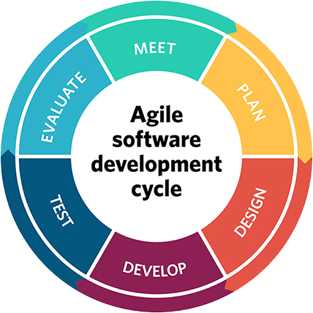

#### Figure 2.2.1 Schematic layout of sequence of operation

# CHAPTER 3:

## INTRODUCTION TO INTERNSHIP AND INTERNSHIP MANAGEMENT

* 1. **INTERNSHIP SUMMARY**

Internship is the best was to make a shift from academics to professional life and to get introduced to the corporate culture. Initially, there was a training period, wherein we were made re-familiar to previously studied methodologies, after which the project “Furniture Recommendation system” was assigned.

Furniture Recommendation system is a system based on the Collaborative filtering method in which the uploaded image from the user is go through the feature extraction and for the feature extraction is done using the transfer learning model. The model is based on the convolutional neural networks.It is a deep learning model that has achieved state-of-the-art performance in image classification tasks, particularly in the ImageNet Large Scale Visual Recognition Challenge (ILSVRC) competition.

After the generated features the features are compared with the training dataset image generated features and to find the similarity between to images the k-nearest neighbors algorithm is used.

The main part of the project is a model only through which the recommendation is made and the performance of the model on different images.

## Purpose

The main purpose of this internship is to gain practical experience in the corporate world, to use various technologies in the industry and to gain knowledge on how to adapt in a professional environment. It also taught me to communicate with different clients in a professional manner through business meetings.

## Objective

The main objectives of this internship are:

* + - To learn technological usage at professional level with proper standards.
    - To learn how to interact with clients, seniors, colleagues etc.
    - How to represent yourself at the industry level.
    - To learn how to work in a team with collaborative tools like git, skype meeting, personal workspace, etc.
    - Throughout the project, how to amend client requirements into live project

The main objectives of this project are:

* Furniture recommendation systems are designed to enhance the user's shopping experience by providing personalized and relevant product recommendations..
* By reducing the time and effort required for users to search for furniture items, these systems can improve customer satisfaction and increase sales for businesses.

## Scope

The scope of the internship at the company was to help in developing quality products for customers.

* The proposed project would be very useful in E-Commerce websites and mobile application through which the user likes to order the furniture items.
* The project is resolves the issue of choosing right product.
* The project improve productivity and improve user satisfaction and user experience.

## Technology and Literature Review

The below technologies were taught during the training period of the internship. For being able to work on a project, we were given initial training of a Machine Learning.

### Python :

* + - * Python is a high-level, interpreted programming language that is widely used for developing a variety of applications. It was first released in 1991 by Guido van Rossum and has since become one of the most popular programming languages in the world. It encourages lots of machine learning and artificial intelligence application through easygoing syntax.

### Transfer Learning :

* + - * Transfer learning is a machine learning technique that involves using pre-trained models for a specific task as a starting point for a new task. The pre-trained model has already been trained on a large dataset, often using complex architectures and long training times.

### Deep Learning :

* + - * Deep learning is a subset of machine learning that involves training neural networks to learn from large amounts of data. These neural networks are inspired by the structure and function of the human brain and are capable of learning complex patterns and relationships in the data.

### Machine Learning :

* + - * Machine learning is a subset of artificial intelligence that involves training algorithms to learn from data and make predictions or decisions without being explicitly programmed. The algorithms are trained using large amounts of data, and they use statistical and mathematical techniques to identify patterns and relationships in the data..

### Git:

* + - * Git is software used for tracking changes in any set of files, collaboratively developing source code during software development. Its goals include speed, data integrity, and support for distributed, non-linear workflows.

## Internship Planning

### Internship Development Approach and Justification

* The agile software development methodology is used for this project as this project is not a traditional development project and the company used Jira for tracking and managing the project development life cycle, which follows agile methodology also. Jira is also a part of the integrated technology of this plugin so that is why we are using Agile Kanban methodology for developing this project. Also, through the Kanban board, we can easily maintain the development tasks status, track test cycle execution, and also tracking the bugs.



* + **Fig. 3.6.1** Agile Software Development Life Cycle

Agile gives more importance to version control also and through Jira we can easily manage the version system of the plugin.

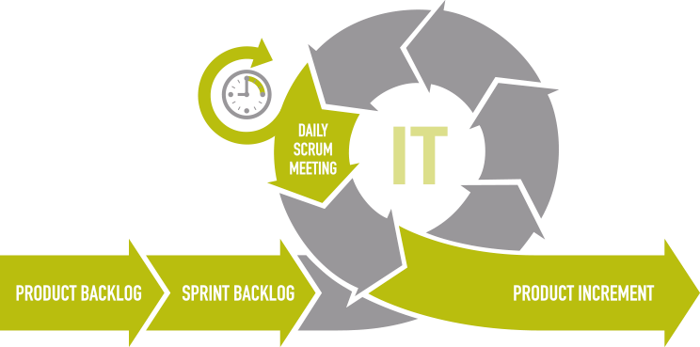

**Fig. 3.6.2** Flow of Kanban Development Methodology

### Internship Effort

* We plan on taking a time-based approach to deliver this product on time. To begin with, we create a set of deadlines to complete certain tasks. This will give us a general idea on how to meet the final deadline on time.

Furthermore, these tasks contain various independent divisions of the software, which can be tested individually. Thus, this will help us report our project in parts and test it as we move along.

* Firstly, we’ll do the API analysis and App understanding in order to have it integrated with Jira. By using Postman, results of hitting the API can be verified and a better idea of the actions to be developed can be made.
* Testing will ensure that our system will work efficiently using all valid values and does not give errors. To test the system, we must perform unit testing, sprint testing and finally the system testing.
* To maintain a system up to date with the changes in the organization and ensuring it meets the goals of the organization by implementing changes to the system when necessary.

### Role and Responsibilities :

**Role :**

Machine Learning intern

### Responsibility :

My role is to find the efficient and most optimal model which can give the highest accuracy and reduce the loss function on the given problem datasets.

# CHAPTER 4:

## SYSTEM ANALYSIS

* 1. **Study of Current System**

Before There is not a single system that provide a recommendation system on this area which can give the recommendation on the basis of their choice. This system helps to improve the user satisfaction and user experience.

## Problems and Weakness of Current system

### Difficulties in finding the right furniture :

It is very difficult to find the perfect furniture design on e-commerce sites which can provide right product while searching for it.

### Time Consuming:

It is a very time-consuming process to find the right furniture of your choice on the internet.

## Requirements of new system

There are two major types of requirements in new system which is mention below:

1. Hardware Requirements
2. Software Requirements

### Hardware Requirements:

* + - * Intel x86 64-bit chip architecture
      * Minimum 1 GB HDD/SDD
      * Minimum 4 GB RAM
      * Mouse, Keyboard

### Software Requirements:

* + - * Windows 7,8,10,11
      * Google Chrome, Mozilla Firefox, Brave, etc.
      * Microsoft Visual Studio
      * Pycharm IDE
      * Git
      * Jira
      * Jupyter Notebook

## System Feasibility

### Economic Feasibility

This system will provide the best furniture option that they can buy in less time which in the long run saves lots of time for the user and give recommendation.

### Technical feasibility

The technical feasibility is satisfied beyond doubt, as modernizing the way of recommending the product means to make good use of the available technology.

## Activity / Process in New System / Proposed System

### Planning:

This is the first phase in the systems development process. Resources, costs, time, benefits and other items should be considered at this stage.

### Systems Analysis and Requirements:

The second phase is where businesses will work on the source of their problem or the need for a change. In the event of a problem, possible solutions are submitted and analyzed to identify the best fit for the ultimate goal(s) of the project.

* CASE (Computer Aided Systems/Software Engineering)
* Requirements gathering
* Structured analysis

### Systems Design:

The third phase describes, in detail, the necessary specifications, features and operations that will satisfy the functional requirements of the proposed system which will be in place. This is the step for end users to discuss and determine their specific business information needs for the proposed system. During this phase they will consider the essential components (hardware and/or software) structure (networking capabilities), processing and procedures for the system to accomplish its objectives.

### Development:

Whole system is designed in this phase (frontend and backend), by satisfying all the functional requirements and non-functional requirements.

### Integration and Testing

Different modules ate integrated in this face and then the whole functionalities are being tasted. This testing will be performed until the end user finds it acceptable. Another part of this phase is verification and validation, both of which will help ensure the program’s successful completion.

### Implementation:

In this phase whole developed system is installed to the client machine and can enjoy the functionality of it.

## Features of New System / Proposed System

* + Responsive design, easily accessible on different devices.
  + Clean and minimalist design
  + Uploading the image on which recommendation is needed.
  + Functionality of viewing each of the images in the bigger window.
  + Functionality to use this recommendation system as web extension.

## Selection of Hardware / Software / Algorithms / Methodology / Techniques / Approaches and Justification HARDWARE REQUIREMENTS

System: Inte i3 core Storage: 8GB

Monitor: 14’ColorMonitor Mouse: Optical Mouse

### SOFTWARE REQUIREMENTS

Operating system: Windows7/8/10/11

Coding Language: Python

Tools: Jupyter Notebook, Pycharm IDE

User Interfce : Streamlit

# CHAPTER 5:

## SYSTEM DESIGN

### General Design of the recommendation engine and overview

* **Types of recommendation Techniques:**

Machine learning solves many problems but making product recommendations is a widely known application of machine learning. There are three main types of recommendation systems –

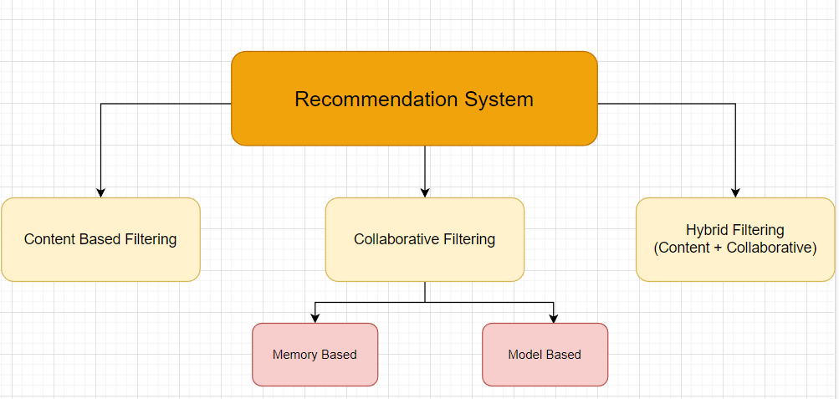

#### Figure 5.1.1 Recommendation types

1. **Collaborative filtering:** This technique recommends items based on the preferences and behavior of similar users. It analyzes user interactions, such as purchases or ratings, to identify patterns and make predictions about what other users might like.
2. **Content-based filtering**: This technique recommends items based on their attributes, such as genre or keywords. It analyzes the characteristics of items that a user has interacted with to recommend similar items.
3. **Hybrid recommender systems**: These systems combine collaborative filtering and content-based filtering to provide more accurate recommendations.

* **LifeCycle of Machine Learning Applications:**

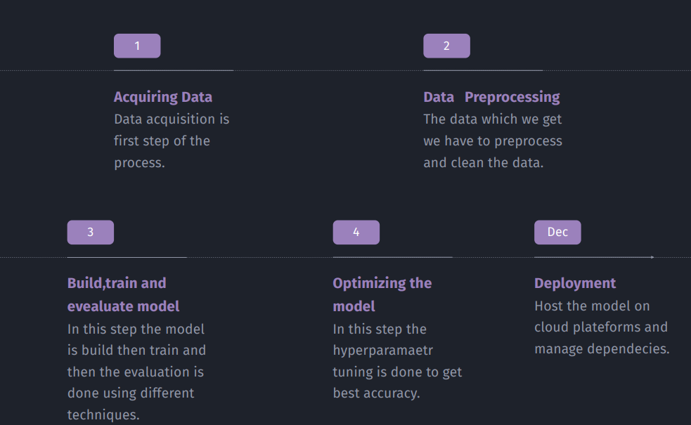

#### Figure 5.1.2 Lifecycle of ML application

Data collection: Collecting relevant data for the problem being solved.

Data preprocessing: Cleaning and transforming the data into a format suitable for training a model.

Model training: Training a model on the preprocessed data.

Model evaluation: Evaluating the performance of the trained model on a separate dataset.

Model deployment: Integrating the trained model into a larger system for use in production.

#### 

### System Design and Methodologies

#### Figure 5.2.1 Use Case Diagram

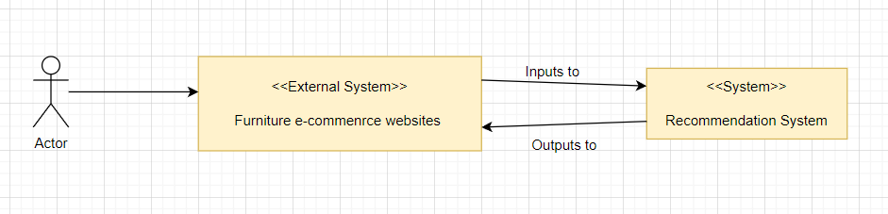

#### Figure 5.2.2 System Context Diagram

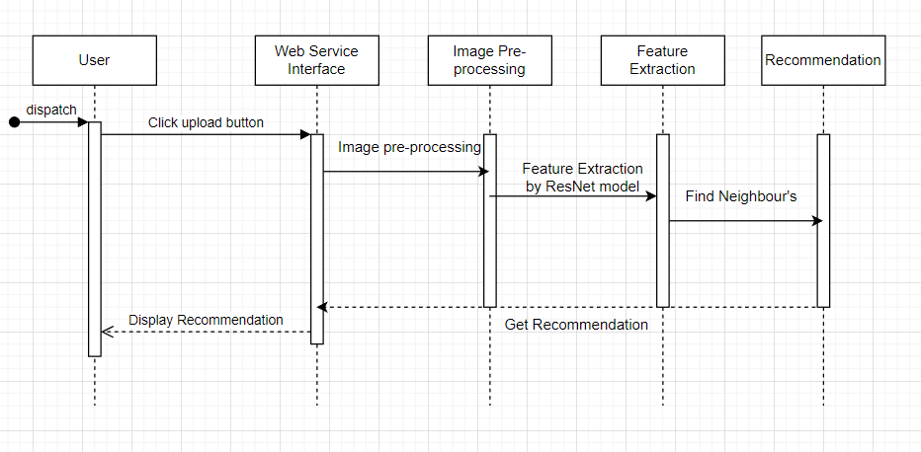

#### Figure 5.2.3 Sequence Diagram

#### 

#### Figure 5.2.4 Block Diagram

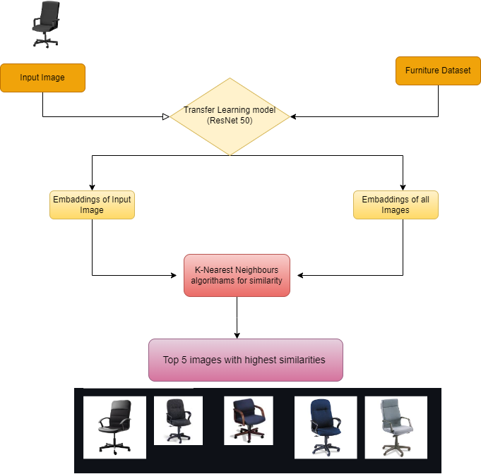

#### Figure 5.2.5 Complete process

### Input / Output and Interface Design

#### 

#### Figure 5.3.1 Home page

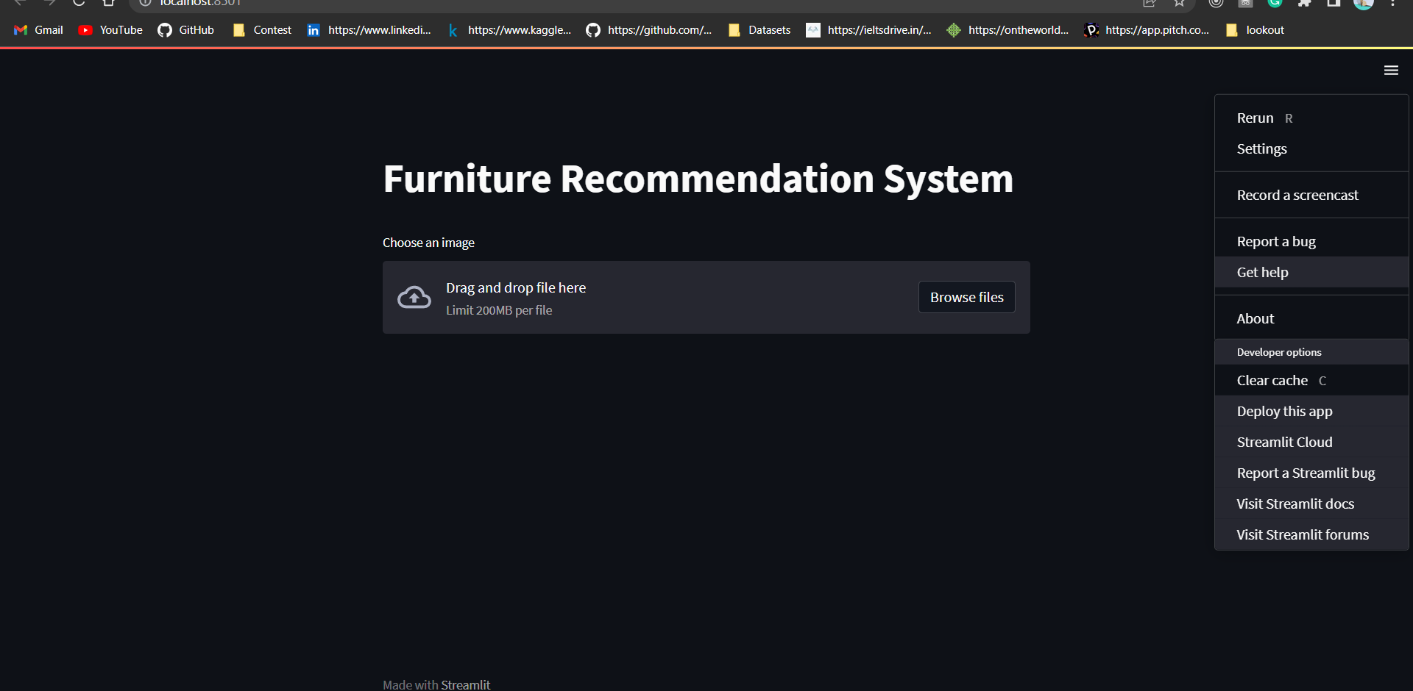

#### Figure 5.3.2 Basic UI

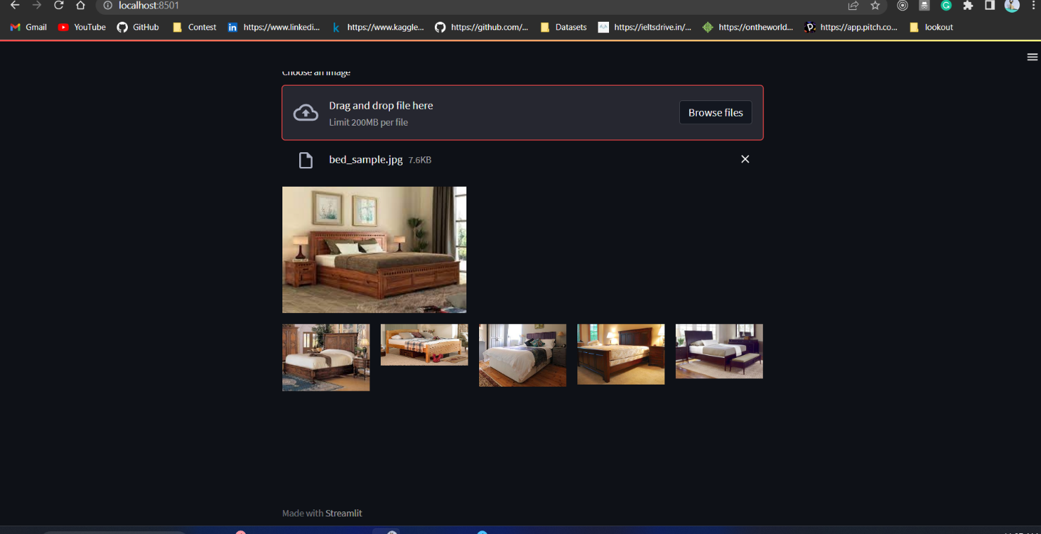

#### 

#### Figure 5.3.3 With recommendation of Bed

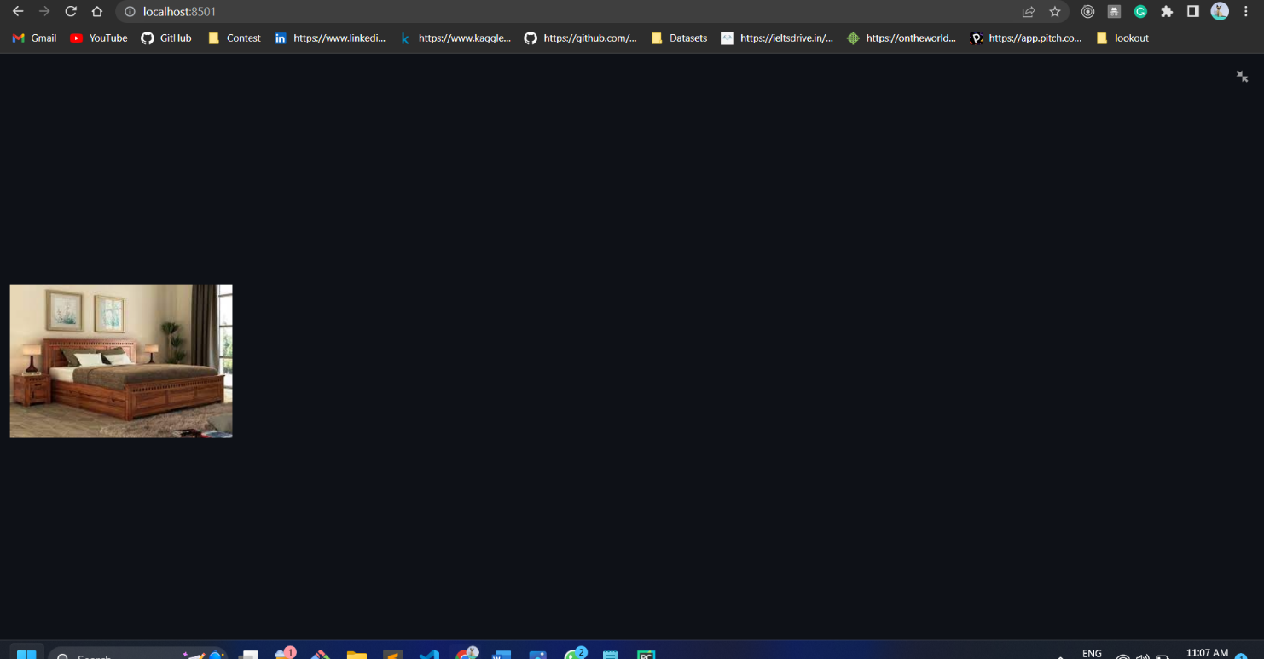

#### Figure 5.3.4 With single image zoom In

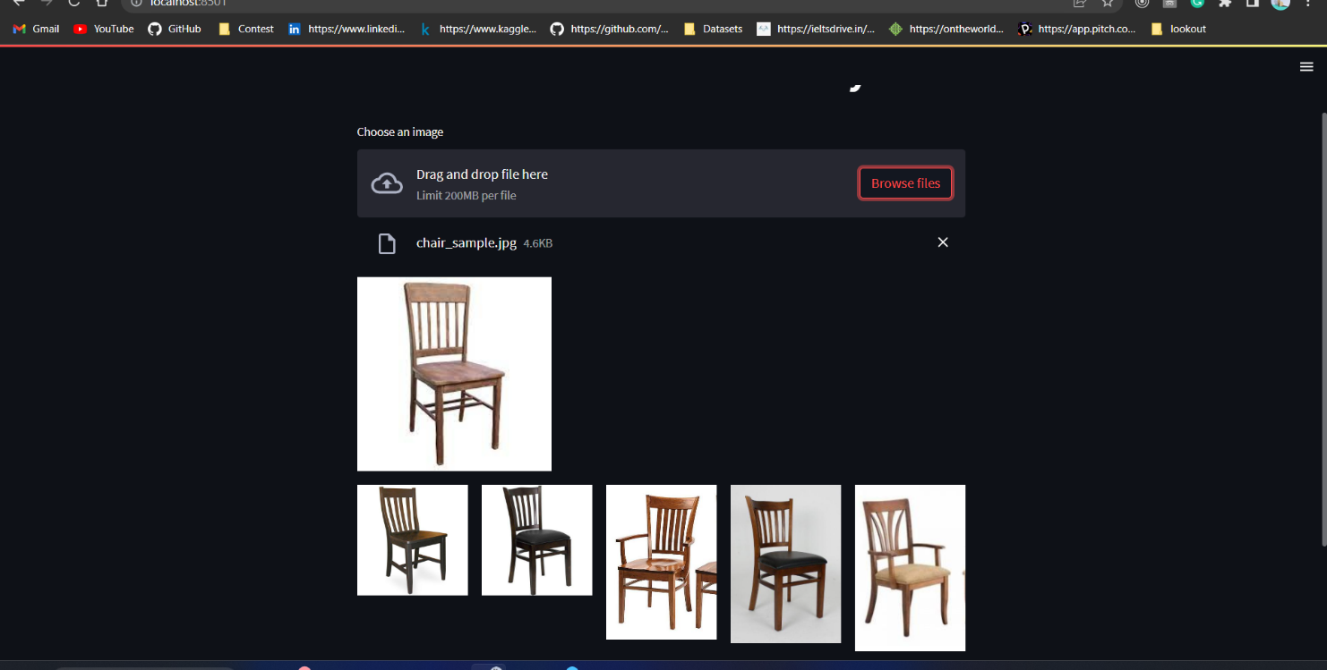

#### Figure 5.3.5 With Chair recommendation

# CHAPTER 6:

## IMPLEMENTATION

### Implementation Platform / Environment

Technologies which are used in our project are as followed

* + - Transfer Learning
    - Machine learning algorithms
    - Image Augmentation
    - Hyperparameter tuning
    - Keras and TensorFlow
    - Image pre-processing

#### Transfer Learning:

Transfer learning is a technique in machine learning where a pre-trained model, usually trained on a large dataset, is used as a starting point for a new task. The pre-trained model already has learned features from the large dataset, and the idea is to use those features as a starting point for the new task, instead of training a new model from scratch.

There are many transfer learning model available which has been already been trained for different kinds of use cases. For example there are several well-known transfer learning models for image datasets like VGG16 and VGG19, ResNet50, WaveNet, BERT, and many more. During internship period I have worked on several of them and in this project after evaluating the performance of each of the transfer learning model ResNet50 is the one which gave efficient results on the given dataset.

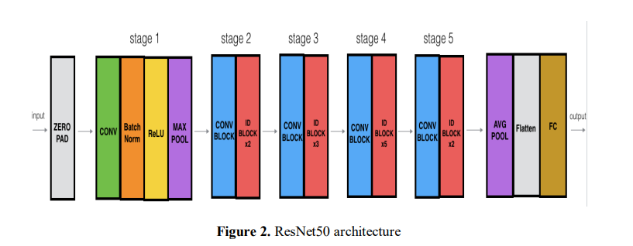

**Figure6.1.1 ResNet50 Architecture**

#### Machine Learning algorithms:

PostgreSQL After Calculating and generating the embeddings to find the similarities between two vectors or two images there are several ways to do that. The first option is two find the Euclidean distance, the other option is to find the cosine similarities between two vectors.And the best option which gives the highest accuracy is Machine learning algoritham called as K-Nearest Neighbour.

KNN can be an effective method for recommendation systems, especially for small datasets. However, it can be computationally expensive for large datasets and suffers from the cold-start problem, where new users or items do not have enough ratings to be used in the KNN algorithm. Therefore, other approaches such as matrix factorization or deep learning-based models may be more suitable for large-scale recommendation systems.

#### Image Augmentation

Image augmentation is a technique used in computer vision and deep learning to increase the size of training datasets and improve the performance of image classification models. The basic idea behind image augmentation is to create new training images by applying various transformations to the original images, such as rotation, scaling, flipping, cropping, and color distortion.

Here in this project the keras very famous ImageDataGenerator is used. It is a built-in image augmentation library in the Keras deep learning framework. It provides a wide range of image transformations, such as rotation, zooming, shearing, flipping, and brightness adjustment.

#### Hyperparameter tuning

For any model it is required to set the hyperparameter in order to get the best accuracy and output. The performance of a model is highly dependent on the choice of hyperparameters, and finding the optimal values can be a challenging task.

There are multiple ways through which the hyperparameter is set for the machine learning model for example there is RandomizedSerachCV() and GridSearchCV() are the method provided in the keras library. In this project the RandomizedSearchCV is used for this tuning.

#### Image Pre-Processing

In order to use transfer learning models the training set images should be of certain amount of shape and it needs to be pre-processed and this model required particular size and in particular batch.

### Process / Program / Technology / Modules Specifications

Entire application divided into 3 parts

* + - UI: Contains all the streamlit code and user interface
    - Feature Extraction for model: Features are extracted form the given training dataset using the ResNet50 transfer learning model and saved for the future use with name embeddings.pkl.
    - Actual Model Building and finding similarities: Contains all the information about the model and features list.

### Result Analysis / Comparison / Deliberations

As the system is digitalized, problems like Data Inconsistency, Data Security, Data Redundancy, etc. will not arise. These were the primary drawbacks of the traditional system which has been used for years by attorneys all around the world. And the system will provide ease on hand by selecting the best recommendation for the needs the users are looking for.

# CHAPTER 7:

## TESTING

### Testing Plan / Strategy :

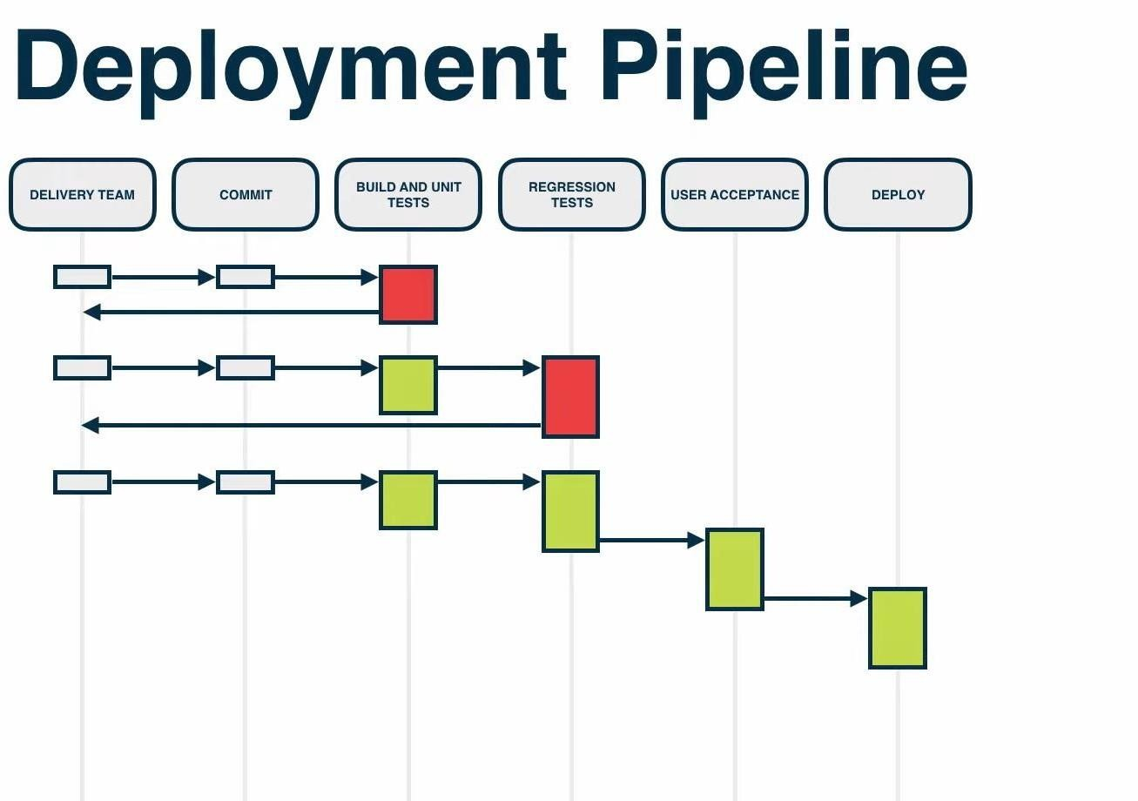

**Fig. 7.1.1** Deployment Pipeline

In agile methodology, testing strategies are a plan according to the Deployment Pipeline. As per our testing strategy, we take a build of developer branch in which developer pushed a code after successful Unit Testing and perform testing with Quality Assurance perspective. After completing the development task all developer branches are merged into the master branch and after that Regression and Integration Testing is performed. After completed Regression and Integration, Sanity testing is performed on the sprint build. After that, if no bugs are there then the product is successfully released.

## Test Suites and Test Cases

### Manual Testing

In manual testing, the tester will check all the essential features of the given application. In this process, the software tester executes the test

cases and generate the test reports without the help of any automation software testing tools. It is a classical method of all testing types and helps find bugs in software systems.

# Unit Testing

Unit testing is a type of software testing where individual units of a software are tested. The purpose is to validate that each unit of the software code performs as expected. Unit Testing is done during the development of an application by the developers.

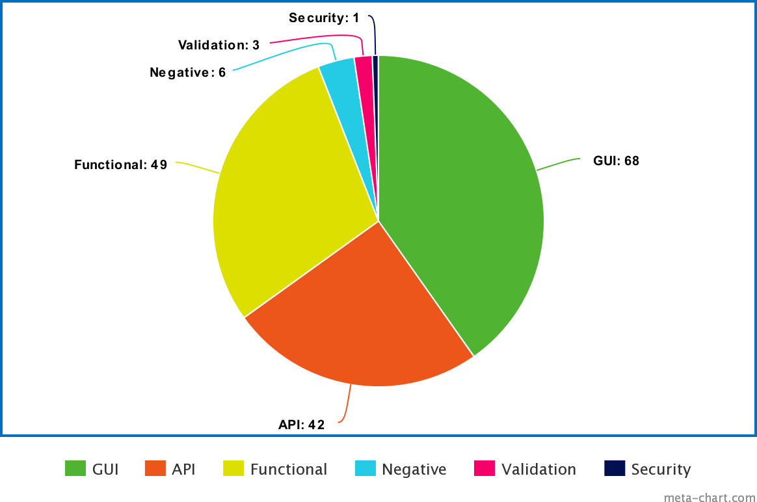

**Fig. 7.2.1** Test Case Classification

# CHAPTER 8:

## CONCLUSION AND DISCUSSION

* 1. **Conclusion**

The internship activities are about understanding and analyzing requirements to follow the pattern of designing solutions with a thorough understanding of the project and requirements of its. In internship we learn how to write code in industries. Also learn how to work with team. The other point was to be a team member. We were given projects in the team so the spirit of the team can be learned and with the team, we can achieve great results and we can learn many aspects of working in a team environment and we can also learn from many perspectives through thoughts of team members.

### Summary of Internship / Project work

The internship gave me true and practical way of using programming and tools to develop an application. In the internship I have learned so many things to help me become better engineer. Also I learn how to do coding in better way and proper way The design and logic are the two things that I have learned a lot during the internship. Practical, maintainable, readable code is the best code.

### Limitation and Future Enhancement

#### Limitations:

* + - K-Nearest Neighbors algorithm is high computational for large dataset so there should be some other approach is needed.
    - User can not see the product description and detailed review which can be benefitable for user experiance.

#### Future Enhancements:

* We can make the web extension in which if the user is monitoring any product then the extension will show the similar product on the internet .
* There can be some more features on which the recommendation can be done like the size of the furniture and the material which may increase the chance of recommendation to be true.
* The web app UI should be improved with the functionalities like link to the product so that the user can directly look on to the official product store.
* It should be more on general side and not only on the furniture based.

**REFERENCES**

* Reserch Paper on the topic <https://shorturl.at/lpDK6>
* ResNet50 Architecture : <https://towardsdatascience.com/the-annotated-resnet-50-a6c536034758>
* KNN Documentation : <https://www.datacamp.com/tutorial/k-nearest-neighbor-classification-scikit-learn>
* research perspective on recommender systems :<https://journalofbigdata.springeropen.com/articles/10.1186/s40537-022-00592-5>
* Image Augmentation : <https://machinelearningmastery.com/image-augmentation-deep-learning-keras/>
* Hyperparameter Tuning : <https://keras.io/guides/keras_tuner/>
* Image Pre-Processing : <https://www.mygreatlearning.com/blog/introduction-to-image-pre-processing/>
* Stack Overflow : <https://stackoverflow.com/>